Week 13 pda evidence

|  |  |  |  |  |
| --- | --- | --- | --- | --- |
| **Week 13** | **Unit** | **Ref.** | **Evidence** | **Done** |
| P | P 1 | Take a screenshot of the contributor’s page on Github from your group project to show the team you worked with. |  |
| P | P 2 | Take a screenshot of the project brief from your group project. |  |
| P | P 3 | Provide a screenshot of the planning you completed during your group project, e.g. Trello MOSCOW board. |  |
| P | P 4 | Write an acceptance criteria and test plan. |  |
| P | P 7 | Produce two system interaction diagrams (sequence and/or collaboration diagrams). |  |
| P | P 8 | Produce two object diagrams. |  |
| P | P 9 | Select two algorithms you have written (NOT the group project). Take a screenshot of each and write a short statement on why you have chosen to use those algorithms. | ✓ |
| P | P 17 | Produce a bug tracking report |  |

P1

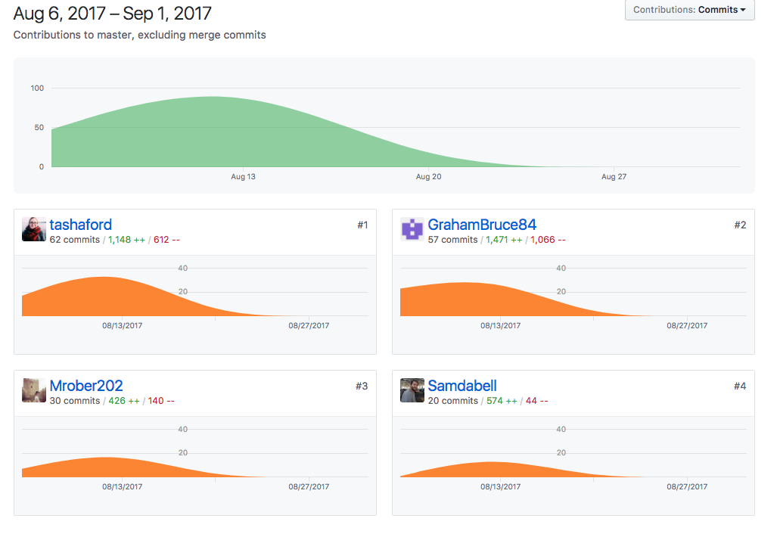

P2

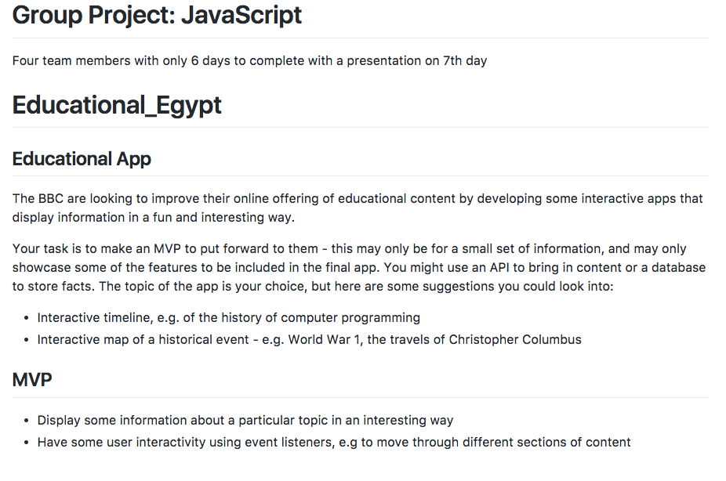

P3

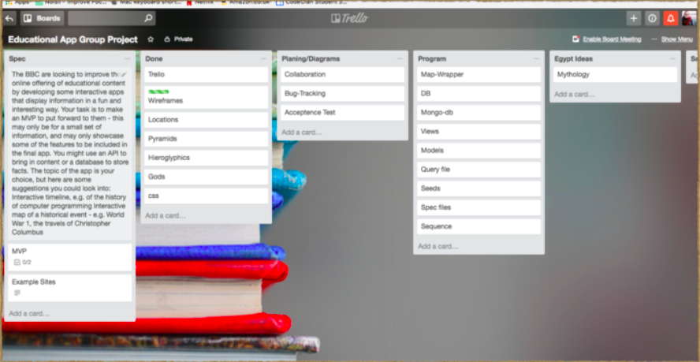

P4

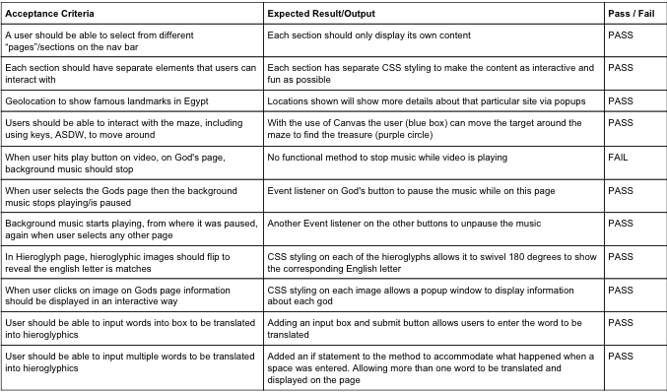

P7

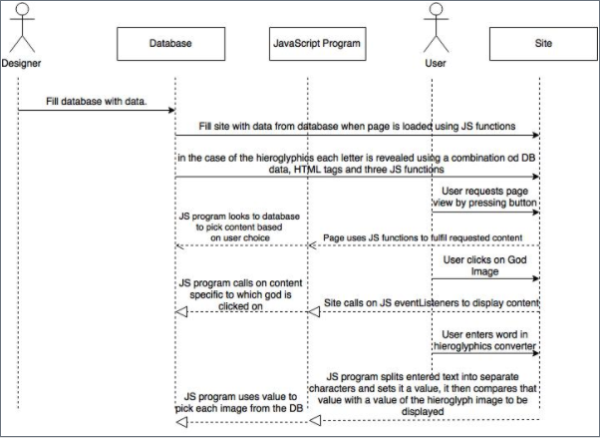

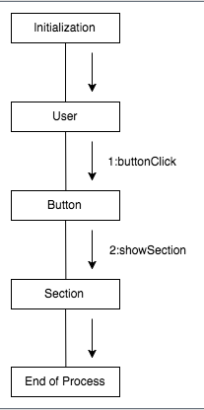

P8

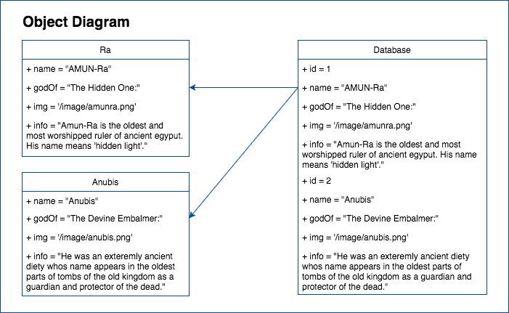

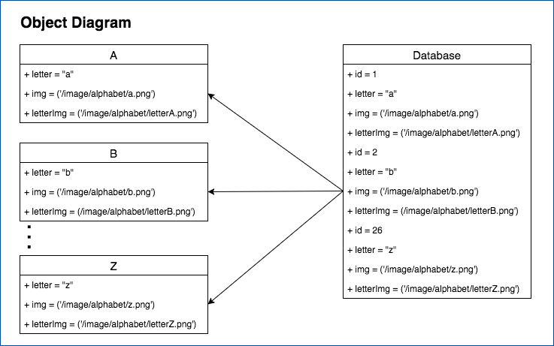

P9

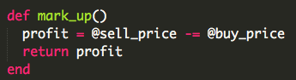

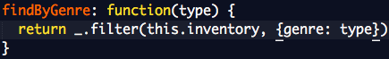

P17

